NANDHA ENGINEERING COLLEGE
ERODE–638052 (Autonomous)

(Affiliated to Anna University, Chennai)



PROJECT BASED LEARNING REPORT

Submitted by

MADHAN V (22AI025)

in partial fulfilment for the award of the degree of

B.Tech (ARTIFICIAL INTELLIGENCE AND DATA SCIENCE)

22AIC15 – FULL STACK DEVELOPMENT

PROJECT BASED LEARNING ON
PRODUCT LANDING PAGE

NANDHA ENGINEERING COLLEGE
(An Autonomous Institution, Affiliated to Anna University, Chennai)



BONAFIDE CERTIFICATE

This is to certify that the project work entitled “PRODUCT LANDING PAGE” is the Bonafide work of MADHAN V (22AI025) who carried out the work under my supervision.

Signature of the Supervisor
Ms. M. Senthamarai,
Assistant Professor,
Department of AI & DS,
Nandha Engineering College,
Erode – 638052.

Signature of the HOD
Dr. P. Karunakaran,
Head of the Department,
Department of AI & DS,
Nandha Engineering College,
Erode – 638052.

Submitted for the project Viva Voce examination held on ______________
ACKNOWLEDGEMENT

I express my thanks to our beloved Chairman of Sri Nandha Educational Trust Thiru. V. Shanmugan and our beloved Secretaries, Thiru. S. Nandhakumar Pradeep of Sri Nandha Educational Trust and Thiru. S. Thirumoorthi of Nandha Educational Institutions for providing me all the basic amenities to complete the course successfully.
I specially thank Dr. S. Arumugam, Chief Executive Officer of Nandha Educational Institutions for his affection and support in all aspects that have made me complete the course successfully.
I wish to convey my earnest gratefulness to our cherished Principal of Nandha Engineering College, Dr. U. S. Ragupathy, M.E., Ph.D., for his constant support in my successful completion of my project work.
I articulate my genuine and sincere thanks to our dear hearted Head of the Department of Artificial Intelligence and Data Science Dr. P. Karunakaran, M.E., Ph.D., and Ms. T. Indhumathi, M.E., Assistant Professor, Department of Artificial Intelligence and Data Science who has been the key spring of motivation to me throughout the completion of my course and my project work.
I wish to convey my heartfelt thanks to my beloved Project Supervisor Ms. M. Senthamarai, M.E., Assistant Professor, Department of Artificial Intelligence and Data Science for her continuous monitoring of the project work.
I am very much gratified to all teaching and non-teaching staff of our department who were direct and indirect strokes throughout my progress. I would like to acknowledge my heartfelt thanks to my parents and my friends who have supported me with their unconditional love and encouragement. Finally, I would like to thank the Almighty for his blessings.

TABLE OF CONTENTS

CHAPTER NO | TITLE | PAGE NO
1 | ABSTRACT | 5
2 | SOFTWARE AND HARDWARE REQUIREMENTS | 6
3 | SOFTWARE DESCRIPTION | 7
4 | PROJECT DESCRIPTION | 9
5 | APPENDIX | 14
6 | SCREENSHOTS | 20
7 | CONCLUSION | 25
8 | SCOPE FOR FUTURE ENHANCEMENT | 26
9 | REFERENCE | 27

CHAPTER 1
ABSTRACT

This project introduces Controllers4U, an innovative e-commerce platform dedicated to bridging the gap between classic gaming nostalgia and modern technological convenience. We offer a curated collection of premium retro gaming controllers, meticulously designed to replicate the authentic feel of beloved vintage hardware while boasting contemporary connectivity and enhanced durability. The application provides a seamless user experience, from intuitive product Browse to secure account management and a straightforward order fulfilment process, making it the ultimate destination for enthusiasts seeking to rekindle their passion for retro gaming with reliable, high-quality peripherals.
The Controllers4U project presents a specialized web application addressing the demand for high-quality, modern-compatible retro gaming controllers. Many enthusiasts face challenges finding reliable vintage hardware or authentic-feeling replicas. Our solution is an intuitive e-commerce site offering meticulously crafted controllers that deliver genuine retro aesthetics and tactile feedback, coupled with the robustness and connectivity required for today's gaming setups. The platform features secure user authentication and a streamlined purchasing system, ensuring a frictionless experience for gamers eager to relive classic moments with superior equipment.By incorporating a component-based architecture and asynchronous data handling, the application ensures a fast, responsive, and user-centric interface. The use of a NoSQL database like MongoDB also allows for easy storage of diverse data types including user details, booking history, and travel package metadata.
This document outlines Controllers4U, a niche e-commerce web application designed to be the premier online destination for retro gaming controller sales. Our focus is on delivering an exceptional user experience, from the moment a user lands on the site to the completion of their purchase. The platform showcases a handpicked selection of authentic-feel retro controllers, each detailed with its unique blend of classic design and modern technological enhancements. With secure login capabilities and an efficient order process, Controllers4U is built to provide unparalleled access and convenience for the discerning retro gamer.
CHAPTER 2
SOFTWARE AND HARDWARE REQUIREMENTS

HARDWARE REQUIREMENTS
System : ASUS
Processor :AMD Ryzen 5
RAM :16GB RAM
Hard Disk Capacity :1 TB

SOFTWARE REQUIREMENTS
Operating System : Windows 11
Frontend :React JS, CSS, HTML
Backend :Nodejs with Express
Database :MongoDB
IDE Used :Visual Studio Code
Browser :Chrome/ Microsoft Edge

CHAPTER 3
SOFTWARE DESCRIPTION

React Js (Frontend Framework):
The Controllers4U user interface would leverage React.js, a leading JavaScript library, for building a dynamic and interactive single-page application. Its component-based architecture would facilitate reusable UI elements for product displays, authentication forms, and the order process. This declarative approach ensures efficient rendering and updates, providing a seamless user experience, with React components managing state and interacting with the backend API for all data operations, including product fetching, user authentication, and order submissions.
Node.js with Express (Backend Framework):
Controllers4U's server-side operations utilize Node.js as the runtime with Express.js for the API backend. This robust combination efficiently handles HTTP requests, defining RESTful endpoints for user authentication (registration, login) and processing customer orders. It securely interacts with the MongoDB database (via Mongoose) to manage user credentials and order details, ensuring seamless data flow and core e-commerce logic.
Express.js as the core Node.js web framework for Controllers4U, Express.js is fundamental to building the backend's RESTful API. It defines and manages API routes (e.g., /register, /login, /order), processes HTTP requests, and sends responses, also enabling crucial middleware like CORS for secure communication.
MongoDB (Database):
MongoDB is Controllers4U uses MongoDB, a NoSQL document database, for persistent data storage. Its flexible, JSON-like document model supports dynamic data for product catalogs, user profiles, and orders without rigid schemas. MongoDB's scalability and high performance ensure efficient storage and retrieval for the e-commerce platform.

Visual Studio Code (IDE):
Visual Studio Code is the primary IDE for the Controllers4U project, utilized for both frontend (HTML, CSS, JavaScript) and backend (Node.js, Express.js) development. Its versatile features, including syntax highlighting, IntelliSense, debugging tools, and extensions, significantly enhance developer productivity and streamline project management.

CHAPTER 4
PROJECT DESCRIPTION
The Photographer Booking System Website features a visually rich and responsive landing page built with HTML, CSS, and JavaScript, integrated with a lightweight Node.js backend. The landing page serves as the user’s entry point to the system and highlights featured services and user navigation.
Frontend Implementation (Static Web Interface)
The frontend files are designed to be lightweight, clean, and easy to navigate. These static files are rendered by the backend server and styled using external CSS for consistency and responsiveness.
  - /src/components – Contains reusable components (e.g., Navbar, Footer, ControllerCard, CallToAction)
  - /src/pages – Contains individual pages (e.g., Home.js, ProductList.jsx, About.jsx, ControllerCard,)
  - /src/App.js – Contains Axios calls like getControllers(), createOrder()
  - /src/api – Axios functions for API communication
Backend Setup (Node.js Server)
The backend of the application is powered by Node.js with Express.js as the routing framework. It serves the static HTML pages and can be extended for REST API integration.
  - /routes – Defines route paths and connects them to controller functions (e.g., userRoutes.js, bookingRoutes.js)
  - /controllers – Contains business logic for handling API requests
  - /models – Defines Mongoose schemas for MongoDB collections
  - /config/db.js – Handles MongoDB connection setup
  - server.js – Starts the Express app and listens for requests
Database (MongoDB)
1.Collections (MongoDB)
- Users:
This collection stores all user-related data including login credentials, personal details, and user roles such as customer or admin. Customers can browse and purchase controllers, while admins can manage the product catalog and orders.
- Controllers:
This collection contains detailed information about PS5 controllers available for sale. It includes fields such as product name, description, color variants, pricing, image URLs, and stock availability. These records are used to render the product listings and detail pages on the frontend.
- Orders:
The Orders collection records all purchase transactions made by customers. Each document contains information like the user ID (who made the purchase), the list of controllers purchased, order date, total amount, and current status (e.g., Pending, Shipped, Delivered, Cancelled).
- Payments:
This collection stores data related to customer payments. It includes the associated order ID, transaction amount, transaction ID from a payment gateway (like Razorpay or Stripe), payment method (e.g., UPI, Credit Card), and status (Paid, Failed, etc.). This ensures secure and verifiable payment tracking.
2.Project Initialization and Setup

A new React frontend application is initialized using the command npx create-react-app ps5-controller-landing. This sets up the foundational structure for building the user interface of the product landing page.
- The Node.js backend is initialized in a separate directory using the command npm init -y, which creates a default package.json file and prepares the project for dependency installation.
- Essential backend packages are installed using npm install express mongoose bcrypt.js,jsonwebtokencors dotenv. These packages provide core functionalities such as server creation (Express), database interaction (Mongoose), user authentication (bcrypt.js and jsonwebtoken), Cross-Origin Resource Sharing (CORS), and secure environment variable management (dotenv).
- MongoDB is connected to the backend using the Mongoose library. This enables the creation of structured data models for Users, Controllers, Orders, and Payments, allowing for efficient storage and retrieval of data in the application.
- A .env file is set up to store sensitive environment-specific configurations such as the MongoDB connection URI, JWT secret, server port, and third-party API keys (e.g., for Razorpay or Stripe). This enhances the security and maintainability of the application by separating secrets from the codebase.
3.User Authentication
- A secure user authentication system is implemented using JSON Web Tokens (JWT) to support both customers and admin users, enabling role-based access and secure session management.
- Users can register and log in to access personalized features such as placing orders, viewing their purchase history, and, for admins, managing product listings and orders.
- Two core authentication routes are created in the backend:
- POST /auth/register allows new users to create an account by submitting their name, email, and password.
- POST /auth/login enables existing users to authenticate and receive a JWT token used for secure session handling.
- Passwords are encrypted using the bcryptjs library before storage in MongoDB, ensuring that user credentials remain secure even in the event of a database breach.
- Middleware is applied to protect sensitive API routes by verifying the JWT token included in incoming requests. This restricts access to certain features based on the user’s authentication status and role, thereby maintaining data integrity and platform security.
4.Controller Product and Order Management (CRUD Operations)
Customers can:
- Browse a catalog of available PS5 controllers, including product details such as name, price, color variants, and high-quality images.
- Filter controllers based on features such as color, price range, or availability.
- View individual controller product pages to explore detailed specifications, pricing, and images.
- Add controllers to their cart and place orders for one or more items through a secure and responsive checkout system.
- Make secure payments through integrated gateways like Razorpay or Stripe.
- Edit or update their user profile, including name, email, and password.
- View or cancel their past and upcoming orders based on order status (Pending, Shipped, Delivered, Cancelled).
Admins can:
- Create, update, or delete controller listings, including uploading new product images, editing pricing, and toggling stock availability.
- Manage customer orders by accepting, processing, shipping, or cancelling them based on business logic.
- View a dashboard of incoming orders, their payment status, and shipment tracking.
- Control inventory by marking products in or out of stock, updating quantities, and modifying product details as needed.
5.Order and Payment Management
- The platform efficiently handles order and payment processes to provide a seamless shopping experience for customers while maintaining administrative clarity for backend operations.
- Order records contain essential details such as the userId (referring to the customer who placed the order), an array of controllerIds (representing the PS5 products purchased), the orderDate (timestamp of when the order was created), the totalAmount (total value of the purchase), and the status of the order.
- Order statuses follow a standardized workflow, starting with Pending (order placed but not yet reviewed), followed by Confirmed (order has been accepted for processing), Shipped (the product is dispatched and in transit), Delivered (the customer has successfully received the product), and Cancelled (order was either canceled by the user or the system).
- Payment records are tightly linked to their corresponding orders via orderId. Each record stores the amount paid by the customer, the paymentMode (such as Razorpay, Stripe, Credit Card, or Cash on Delivery), the transactionId (a unique identifier generated by the payment gateway), and the status of the transaction (e.g., Paid, Failed, or Pending).
- This structured order and payment management system ensures that all transactions are secure, traceable, and integrated with the platform's user and product data, enabling smooth end-to-end eCommerce functionality.
6.Frontend Features – PS5 Controllers Product Landing Page
- The frontend is built with React and styled using CSS (or optionally Tailwind CSS/Bootstrap), delivering a clean, modern, and mobile-responsive user interface that works seamlessly across devices.
- The application consists of several key pages, each focused on improving the shopping and management experience:
1. Home Page: Highlights featured controllers and promotions
2.Shop Page: Browse/filter full catalog by color, price, stock
3.Product Detail: View images, specs, price; add to cart
4.Cart & Payment: Review order, checkout via Razorpay/Stripe
5.User Dashboard: Track orders, edit profile, cancel orders
6.Admin Dashboard: Manage products, orders, and inventory

CHAPTER 5
APPENDIX

<!DOCTYPE html>

<html lang="en">

<head>
<meta charset="UTF-8">
<meta name="viewport" content="width=device-width, initial-scale=1.0">
<title>Controllers4U</title>
<link rel="stylesheet" href="styles.css">
<link rel="icon" href="images/favicon.png" type="image/x-icon">
</head>

<body>

<header id="header">
<img id="header-img" src="images/logo.png" alt="Controllers4U Logo">

<nav id="nav-bar">
<a class="nav-link" href="#features">
Features
</a>
<a class="nav-link" href="#video">Who are we?
</a>
<a class="nav-link" href="#pricing">
Pricing
</a>
</nav>
</header>

<form id="form" action="">
<img id="big-logo" src="images/big-logo.png" alt="Controllers4U Big Logo">
<h2>Join our mailing list for exclusive promotions!</h2>
<input id="email" type="email" name="email" placeholder="Enter your email address here..." required>
<input id="submit" type="submit" value="JOIN US">
</form>

<section id="features">
<h2>Experience Retro Gaming at Its Best</h2>
<p>Controllers4U offers a wide range of high-quality retro controllers designed to enhance your gaming
experience. Whether you're a fan of classic consoles like NES, SNES, or Sega Genesis, we've got you covered.
Here's what makes our controllers stand out:</p>

<div id="feature-container">
<div class="feature">
<img class="feature-img" src="images/feature1.png" alt="Feature 1">
<div>
<h3>Authentic Design</h3>
<p>Our controllers faithfully replicate the look and feel of the original retro controllers,
providing
an authentic gaming experience.</p>
</div>
</div>

<div class="feature">
<img class="feature-img" src="images/feature2.png" alt="Feature 2">
<div>
<h3>Modern Connectivity</h3>
<p>Our controllers are equipped with modern connectivity options, allowing you to easily connect
them to
your favorite gaming platforms and devices.</p>
</div>
</div>

<div class="feature">
<img class="feature-img" src="images/feature3.png" alt="Feature 3">
<div>
<h3>Improved Durability</h3>
<p>We use high-quality materials and robust construction to ensure our controllers are built to
last,
withstanding even the most intense gaming sessions.</p>
<div>
</div>
</div>
</section>
<div style="display: flex; justify-content: center;">
<iframe width="560" height="315" src="https://www.youtube.com/embed/Exkk521qcR0?si=Ewpotu56l5OofdUc"
title="YouTube video player" frameborder="0"
allow="accelerometer; autoplay; clipboard-write; encrypted-media; gyroscope; picture-in-picture; web-share"
referrerpolicy="strict-origin-when-cross-origin" allowfullscreen></iframe>
</div>
<section id="pricing">
<h2>Choose the Perfect Controller for Your Gaming Needs</h2>
<p>Controllers4U offers competitive pricing on all our retro controllers. Here are our popular models:</p>

<div id="controllers">
<div class="pricing-option">
<h3>Classic NES Controller</h3>
<img class="controller-img" src="images/controller1.jpg" alt="Classic NES Controller">
<p>Relive the glory days of the Nintendo Entertainment System with our Classic NES Controller. This
iconic controller features the familiar D-pad, A and B buttons, and provides a nostalgic gaming
experience.</p>
<p class="price">R449.99</p>
<a href="order.html"><button class="buy-now-button">Buy now</button></a>
</div>

<div class="pricing-option">
<h3>SNES Super Controller</h3>
<img class="controller-img" src="images/controller2.jpg" alt="SNES Super Controller">
<p>Experience the magic of the Super Nintendo Entertainment System with our SNES Super Controller. This
controller includes the classic colorful buttons, precise D-pad, and shoulder buttons, making it
perfect for SNES gaming.</p>
<p class="price">R599.99</p>
<a href="order.html"><button class="buy-now-button">Buy now</button></a>
</div>

<div class="pricing-option">
<h3>Sega Genesis RetroPad</h3>
<img class="controller-img" src="images/controller3.jpg" alt="Sega Genesis RetroPad">
<p>Step into the world of Sega Genesis gaming with our Sega Genesis RetroPad. This controller brings
back the memories with its layout of the iconic three-button configuration, enabling you to enjoy
classic Sega games just like you used to.</p>
<p class="price">R529.99</p>
<a href="order.html"><button class="buy-now-button">Buy now</button></a>
</div>
</div>
</section>
<section id="feedback" style="padding: 40px; background-color: #f0f0f0;">
<h2>We’d love your feedback!</h2>
<p>Help us improve by sharing your thoughts.</p>
<form id="feedback-form">
<label for="name">Name:</label><br>
<input type="text" id="name" name="name" required><br><br>

<label for="email-feedback">Email:</label><br>
<input type="email" id="email-feedback" name="email" required><br><br>

<label for="rating">Rating:</label><br>
<select id="rating" name="rating" required>
<option value="5">★★★★★ - Excellent</option>
<option value="4">★★★★☆ - Good</option>
<option value="3">★★★☆☆ - Average</option>
<option value="2">★★☆☆☆ - Poor</option>
<option value="1">★☆☆☆☆ - Bad</option>
</select><br><br>

<label for="comments">Comments:</label><br>
<textarea id="comments" name="comments" rows="4" cols="50" required></textarea><br><br>

<button type="submit" id="submit">Submit Feedback</button>
</form>

<script>
document.getElementById("feedback-form").addEventListener("submit", async function (e) {
e.preventDefault();

const feedbackData = {
name: document.getElementById("name").value,
email: document.getElementById("email-feedback").value,
rating: parseInt(document.getElementById("rating").value),
comments: document.getElementById("comments").value,
};

try {
const response = await fetch("http://localhost:3000/feedback", {
method: "POST",
headers: {
"Content-Type": "application/json",
},
body: JSON.stringify(feedbackData),
});

const result = await response.json();
if (result.success) {
alert("✅ Thank you for your feedback!");
document.getElementById("feedback-form").reset();
} else {
alert("❌ Error: " + result.message);
}
} catch (error) {
console.error("❌ Error submitting feedback:", error);
alert("Server error while submitting feedback");
}});
</script> </html>
CHAPTER 6
SCREENSHOTS

- Home page
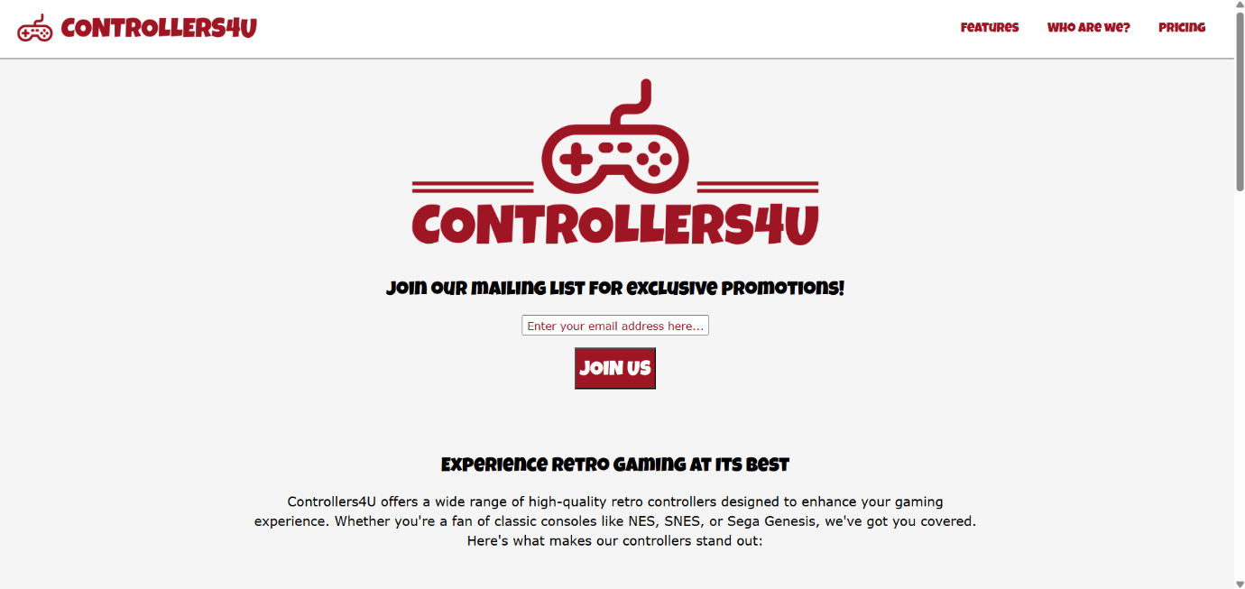

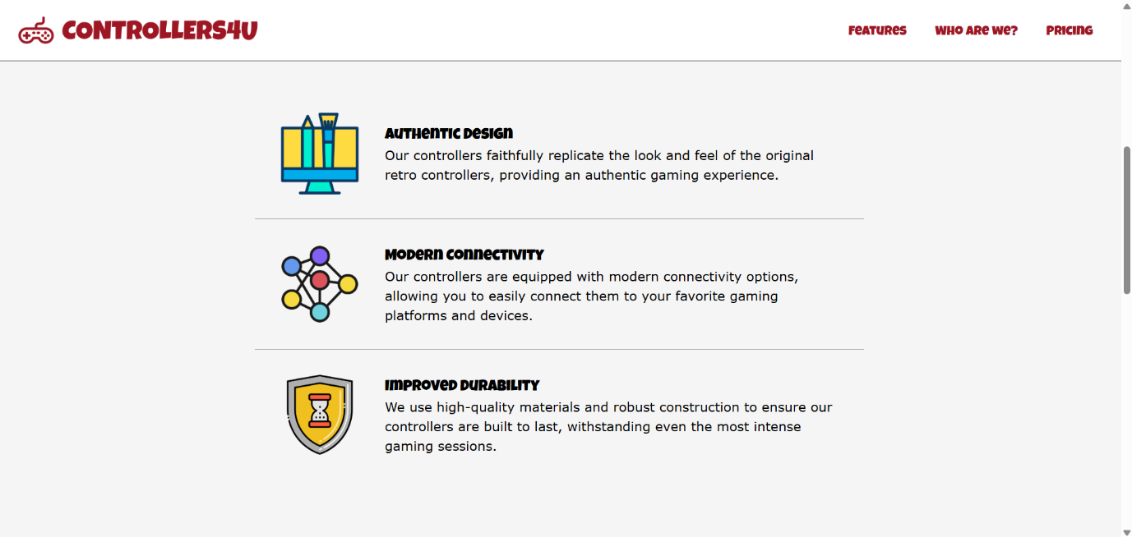
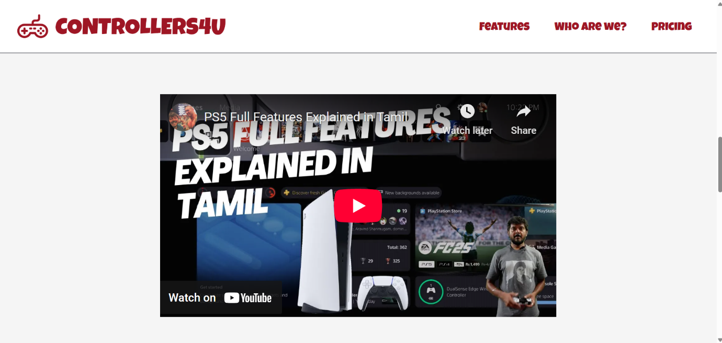

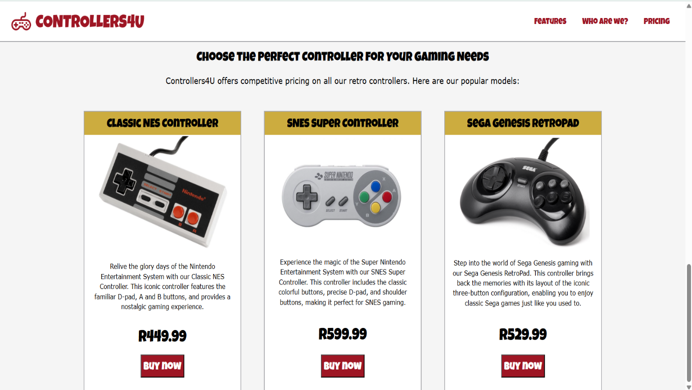

- Register Page

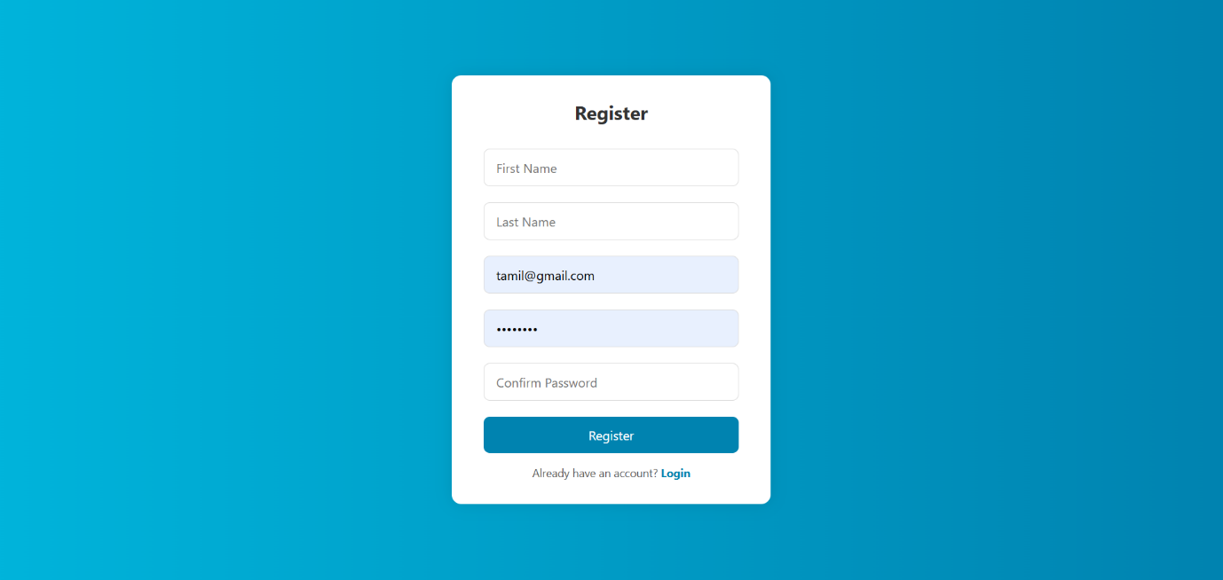

3.Login Page

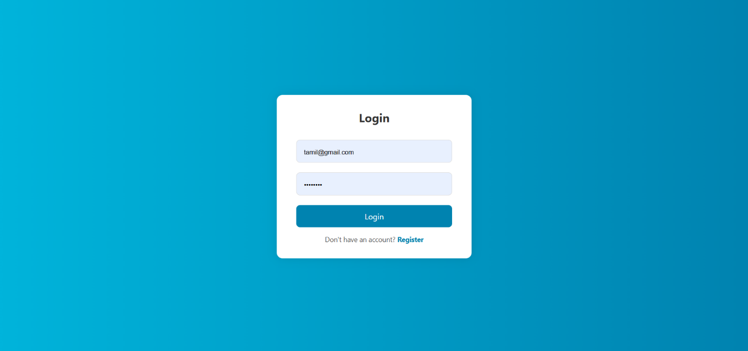

4.Order Page

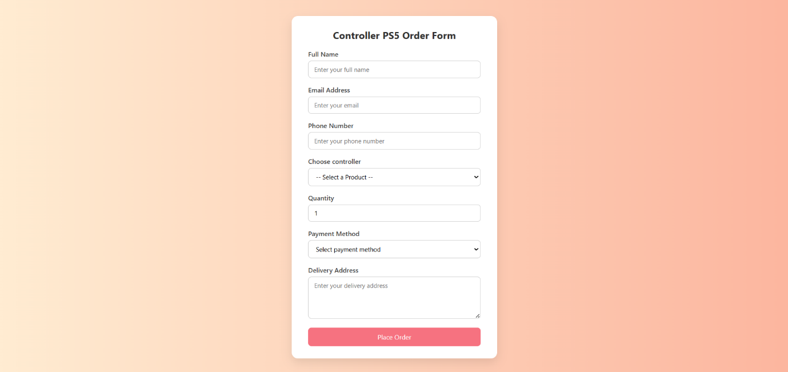

5. MongoDb

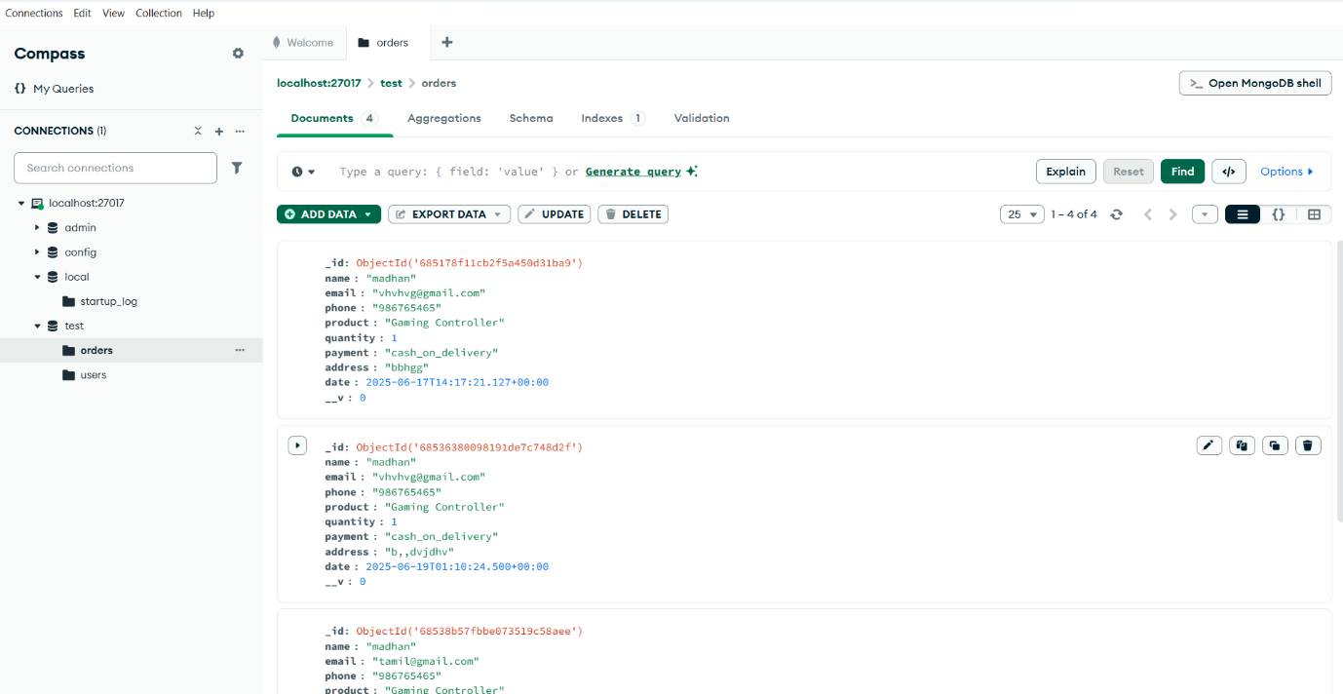

6.Feedback

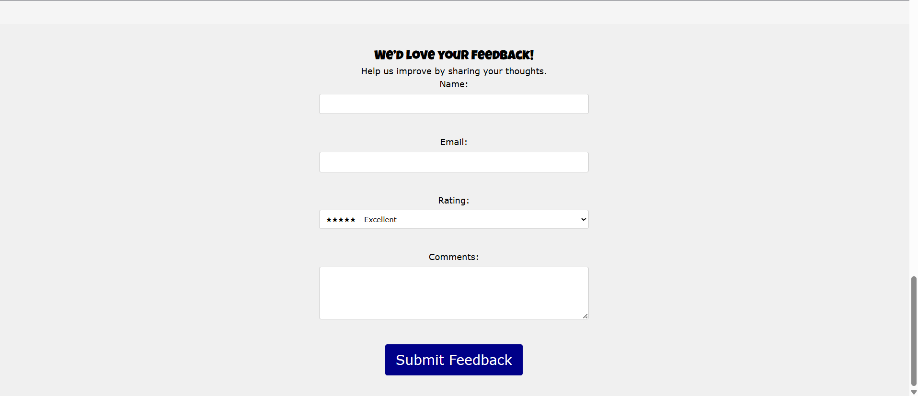

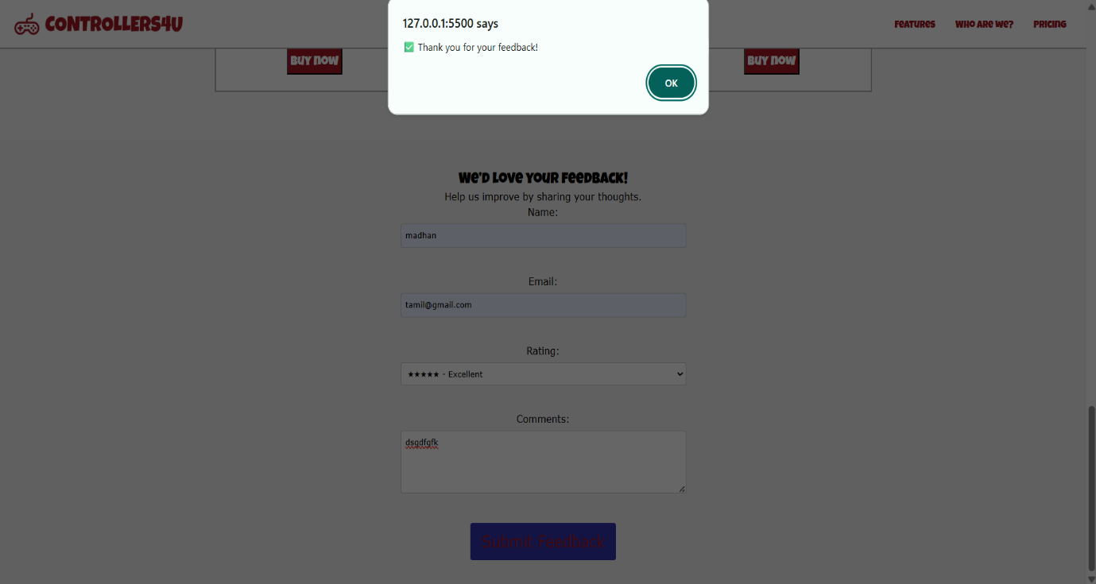

CHAPTER 7
CONCLUSION
The PS5 Controller product landing page successfully showcases the controller’s features, design, compatibility, and user benefits in a visually engaging and user-friendly layout. It provides an optimal user experience through clean design, responsive layout, and well-placed call-to-action elements. The integration of modern web design practices ensures the page is both informative and persuasive, effectively supporting marketing and sales strategies.

CHAPTER 8
SCOPE FOR FUTURE ENHANCEMENT

- E-commerce Integration:
Add cart functionality and secure checkout to convert it into a full shopping platform.
- User Reviews & Ratings: Allow users to post reviews and rate the controller for better engagement and credibility.
- Localization: Support for multiple languages and regions to target a broader audience.
- Interactive 3D Model: Integrate a 360° view or 3D model for better product visualization.
- AI Chatbot Support: Provide real-time support and product recommendations using AI chatbots.

CHAPTER 9
REFERENCES

[1] M. Haverbeke, Eloquent JavaScript: A Modern Introduction to Programming, 3rd ed. No Starch Press, 2018.
[2] A. Banks & E. Porcello, Learning React: Functional Web Development with React and Redux, 2nd ed. O’Reilly, 2020.
[3] V. Subramanian, Pro MERN Stack: Full Stack Web App Development with Mongo, Express, React, and Node.js, 2nd ed. Apress, 2019.
[4] UNWTO Report: Digital Transformation in Tourism.
[5] Node.js Official Documentation.
[6] Full stack Open – Modern React ( https://fullstackopen.com/en).
[7] Express.js Guide.
[8] MongoDB: The Definitive Guide, 3rd Ed. – Shannon Bradshaw, Eoin Brazil
[9] Mastering Mongoose – Valeri Karpov

